Kentucky Academy of
Eye Physicians and Surgeons

2017 Spring Meeting
Comprehensive Ophthalmology Conference

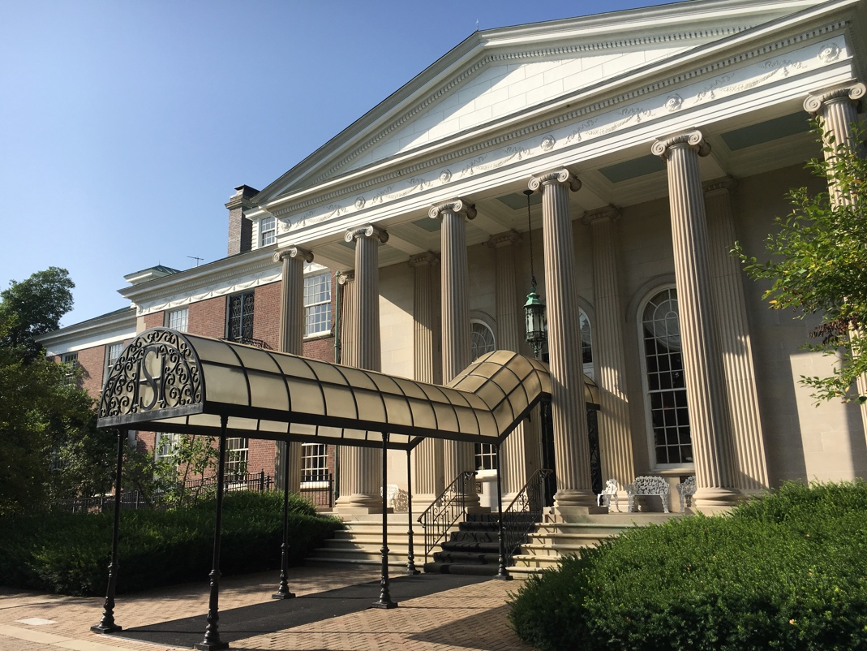

Spring Scientific Seminar
Cataract Update
Ophthalmic Technician Program
Practice Administrators’ Insurance Panel

April 21-22, 2017
The Club at Spindletop Hall
Lexington, Kentucky

KENTUCKY ACADEMY OF EYE PHYSICIANS AND SURGEONS (KAEPS)
ANNUAL MEETING & SPRING SCIENTIFIC SEMINAR REGISTRATION

April 21-22, 2017

MEETING DIRECTORS
Carl Baker, M.D., KAEPS President
Frank Burns, M.D., KAEPS President-Elect
Chip Richardson, M.D., KAEPS Treasurer

LOCATION/HOTEL
The Club at Spindletop Hall
3414 Iron Works Pike
Lexington, Kentucky 40511
859-255-2777
www.spindletophall.org

CME ACCREDITATION
Accreditation for Physicians: This activity has been planned and implemented in accordance with the Essentials and Standards of the Accreditation Council for Continuing Medical Education through the joint sponsorship of the Indiana Academy of Ophthalmology (IAO) and the Kentucky Academy of Eye Physicians and Surgeons (KAEPS). The Indiana Academy of Ophthalmology, Inc. is accredited by the Indiana State Medical Association to sponsor continuing medical education for physicians. The IAO designates this educational activity for a maximum of 8.5 AMA PRA Category 1 Credit(s)™. Physicians should only claim credit commensurate with the extent of their participation in the activity.

This conference is designed to provide ophthalmologists with information on practical issues useful in their daily practice as well as recent research findings in clinical care. During the conference, physicians should gain knowledge about the medical and surgical care of cataracts, IOLs, care of patients with diabetic retinopathy and better coding and documentation for patient care.

Disclosure Policy: It is the policy of KAEPS that any faculty (speaker) who makes a presentation at a program designated for AMA Physician’s Recognition Award (PRA) Category I or II credit must disclose any financial interest or other relationship (i.e. grants, research support, consultant, honoraria) that faculty member has with the manufacturer(s) of any commercial product(s) that may be discussed in the educational presentation.

Program Planning Committee Members must also disclose any financial interest or relationship with commercial industry that may influence their participation in this conference.

In accordance with the Accreditation Council for Continuing Medical Education requirements on disclosure: information about relationships of presenters with commercial interests (if any) will be included in materials distributed at the time of the conference.

PREMIUM DISCOUNT FOR OMIC INSURED
OMIC will provide an approved risk management course. KAEPS members who attend the OMIC risk management breakfast on Saturday, April 22 will receive a 10% discount on their 2017 OMIC premium.

JCAHPO ACCREDITATION
The ophthalmic technician course has been submitted to JCAHPO for consideration of CE credit.

PHYSICAL ASSISTANCE/DIETARY REQUIREMENTS
Those attendees who need additional assistance should contact the KAEPS Office at 859-948-4626 so that appropriate arrangements can be made.

PHYSICIAN COURSE DESCRIPTION
This program has been developed from physician forums, member evaluations and comments in an effort to provide the latest information to KAEPS members on new diagnostic and surgical procedures in ophthalmology. This meeting of lectures and question and answer sessions will provide information concerning updates in ophthalmic treatments and surgery. In addition, changes in the regulatory and economic environments will be explored. Comprehensive ophthalmologists as well as subspecialists will benefit from attendance.

KOPAC BOURBON TASTING AND WINE BAR
As a welcoming reception, a bourbon tasting and wine bar will be held in the exhibit area on Friday, April 21 from 6:00 to 8:00 pm. A select group of bourbons will be featured, along with a wine, beer and soda bar. This event is a fundraiser for KOPAC. Checks should be made payable to KOPAC. Attendees, spouses, guests, administrators, technicians and exhibitors are welcome to attend.

THIS CONFERENCE IS PAPER LITE
KAEPS is working to reduce the amount of paper we use at our conferences and symposia. Electronic program materials received in advance will be accessible online before, during, and after the program on the KAEPS website. (Details available at conference.)

QUESTIONS
For additional questions, please contact Jamie Ennis Bloyd, Executive Director, at 859-948-4626 jamie@kyeyemds.org.

APRIL 21-22, 2017 ANNUAL MEETING AND SCIENTIFIC SEMINAR
REGISTRATION

MD Name:

Practice Name: _______

Email address: _______
Return to:

KY Academy of Eye Physicians and Surgeons – 4781 Firebrook Blvd, Lexington, KY 40513

Or scan and email to jamie@kyeyemds.org

Cancellations:
Cancellations must be received by March 31. All cancellations must be in writing and emailed to the KAEPS office at Jamie@keyemds.org.

Check if you need any auxiliary services identified in the Americans with Disabilities Act.

*Event submitted for CE accreditation through the
Indiana Academy of Ophthalmology.

Spouse/Guest’s Name Attending:

PHYSICIAN REGISTRATION FEES
One day: $100 - 4 CME Credits – Member Rate
Two days: $150 – 8.5 CME Credits – Member Rate
One day: $550 – 4 CME Credits – Non-Member Rate
Two days: $600 – 8.5 CME Credits – Non-Member Rate

Please note that registrations submitted after March 31, 2017 or
turned in at the door will be subject to a $50 late fee.

Please Indicate the Day(s) You Plan to Attend
Friday Only
Saturday Only
Friday and Saturday

OPHTHALMIC TECHNICIAN Fees
Program on Friday, April 21, 2017

Registration - $75 per technician of a member’s practice – 4 JCAHPO Credits
$200 per technician of non-member’s practice – 4 JCAHPO Credits
Please fill out the table below for any technicians attending the program:

First Name | Last Name | Title | Email Address  For Confirmation

